Vector Measurements or step diagonal
Comparison between the results of Vector method and Traditional

Gianmarco Liotto

Optodyne Laser Metrology s.r.l.
Via Veneto, 5 20881-Bernareggio (MB )
tel. 039 6093618 optodyne@optodyne.it

Abstract
In order to obtain a better positioning accuracy in a machine tool it is important the measurement of volumetric error, that includes the linear position errors, the geometrical errors of straightness and squareness of all the 3 axes and the sag and deformation errors. The check of dynamic behavior complete the information on the machine status.

With the new CNC generation it is possible to obtain better performance machines even at better prices using the software compensations providing the errors are repeatable and easy measurable. In this document it is described a new method for the measurement of the volumetric error of a Machine Tool or CMM.
The vector method measure the vector errors, that are the linear positioning error, the vertical straightness error, the straightness horizontal error, instead of the linear position error like the traditional interferometer. It is also possible to measure the angular errors and the errors due to the sag on non rigid body. The measured errors are used for the machine compensation. Are described the basically concepts, shortly the theory and the measurements errors, the experimental verification in comparison with a conventional compensation.

Introduction

The performances or the accuracy of a CNC are commisurated to the linear positioning error, to the straightness errors , to the angular errors and to the elastic errors. A complete measurement of those errors is very complex and time consuming, for those reason the diagonal measurement of the body diagonal is recommended by many international standards like ISO 230 and ASME B5.54 for a fast check of the volumetric accuracy. This because the diagonal measurements is sensible to all the error components. However, if the errors exceed the specification, with the diagonal measurement only there are not enough information for the identification of the error sources and for their compensation.
The characterization of the machine movement it is very complex. For each movement axis there are 6 degree of freedom and consequently 6 errors: linear in X, of straightness in the Y and Z direction, pitch, roll and yaw angles. For a 3 axes machine there are 18 errors plus squareness for a total of 21 errors.
The machine accuracy con be improved with the measurement and the compensation of such errors providing the machine is repeatable.
The Vector Measurement Techniques or in other words the method of Step Diagonal Measurement Techniques can measure all those volumetric errors using a LDDM Laser Doppler Displacement Meter that is a new generation laser interferometer with a single beam and single aperture, able to easily use a flat mirror as target.

II. Concept of the diagonal measurements

Diagonal Measurement
The diagonal measurement method is recommended for a fast examination of the positioning and geometrical performances of the machine in all its components. Practically is the measurement of the position accuracy by a laser interferometer. A retroreflector is applied to the spindle and illuminated by a laser beam, that is aligned along the machine diagonal, for example from the lower left corner (X=0 Y=0 Z=0 denominated NNN) to the upper right corner (Xmax. Ymax. Zmax. denominated PPP). Is measured the zero position and at each increment of the three axes, that are moved together to reach the new position along the diagonal. The accuracy of each position along the diagonal depends to the positioning accuracy of the three axes, but also, and normally mainly, by the machine geometry. In conclusion it is a good method for the machine verification, but there are not enough information for the identification of the error sources.

2. Step Diagonal Measurement
The new Vector measurement method or Step Diagonal Measurement Method differs from the traditional method because each axis is moved singularly ond the positioning error is collected after each singular movement of the X axis, of the Y axis and than of the Z axis. For this reason the positioning error due to the singular axis movement can be separated. The collected data can be processed as the projection of the displacement of each singular axis along the diagonal. It is possible to determine the positioning errors together with the straightness errors for each one of the three axes.

Scheme of the step diagonal measurement.

The working volume is ideally divided into elementary blocks and the measurement is done for each side of the blocks along the diagonal path.
X
Y
Z

3. Theory
To know more about the theory for the Vector method, models and formulae please see the following documentation: Volumetric Error Measurement and Compensation using the Vector Method, Part 1: Basic Theory - Charles P. Wang –Optodyne,Inc. 1180 Mahalo Place Compton, CA90220 USA tel 310-635-7481
The document con be downloaded at the following address: WWW.OPTODYNE.COM

III. Experimental verification

- Measured Machines
The measuring test was performed on two type JOBS-LINKS Compact 5ax in the Piacenza facility. Have been taken in consideration two machines of the same model and dymentions, the first was checked in his geometrical performances with traditional methods and was inside the tolerances, and was compensated for the linear positioning error. After that was measured the volumetric positioning accuracy. The second machine, without any compensation, was measured with the Vector method or step diagonal measurement. All the errors was measured and automatically generated the 24 correction tables that allowed the global machine compensation. The verification of the compensation was performed with the traditional interpolated diagonal as it the first machine verification. Was also performed statistical verification, dynamic axis interpolation, dynamic step verification and also some geometric measurement of straightness.

2. Instrumentation
Into the conventional diagonal the target trajectory is a straight line and it is possible to use the corner cube as target that can tolerate a lateral displacement of 5 mm (.2 in). In the step diagonal the movement is alternatively along the X axis, than along Y axis an than along the Z axis. And repeated in order to reach the opposite corner of the diagonal. The trajectory of the target is no a straight line and the lateral movement is quite large. For this measurement it is not possible to use a traditional interferometer that cannot tolerate such lateral movement. For this reason was utilized a laser interferometer with a single beam and single aperture based on Doppler effect that is possible to be used with a standard corner cube but also with a flat mirror as target. It is noted that with a flat mirror as target, the movement parallel to the mirror do not displace the beam and do not change the distance from the source so the measurement is not influenced. Hence, it is measured the movement along the beam only and tolerated a large lateral movement of the target.
The laser calibration system, denominated Laser Doppler Displacement Meter (LDDM) OPTODYNE model MCV500 it is a new generati laser interferometer baser on Doppler effect at single beam and single aperture, so the laser beam reflected by the target reenter in the same emission aperture. The system is completed by an alignment mirror to easy bend the beam on the diagonal.
As targets on the moving part of the machine, was used a half inch (12mm) corner cube and a 3" by 4" (75 X 100 mm) flat mirror . For the dynamic coordination or Laser /Ballbar was utilized a flat mirror 6 " long (150mm). The retroreflector for the step dynamic test is a little corner cube of 4mm dia (.15") bonded with anelastic glue. The automatic data acquisition, the error analysis and the automatic generation of the compensation table, was performed by the Optodyne LDDM Widows software version 2.43 and by Wincatch software.

IV. Measures on the first machine by the interpolated diagonal.

- Measure preparation

The machine have been measured along the 4 body diagonals by means of interpolated movements of the 3 axes. The laser was mounted on the machine table and by the bending mirror the beam aligned parallel to the diagonal. The corner cube was connected to the spindle as shown in the fig. 1. The machine was programmed to move the spindle starting from one corner and arriving to the opposit corner. Have been used all the linear pitch error compensation already loaded in the CNC controller. The Laser beam was aligned parallel to the to the diagonal movement. the typical tolerance alignment is better than 0.5 m Rad. or 2mm at 4 m distance.

- Collection and analysis of Volumetric accuracy

The positioning error was measured by a single aperture laser Doppler (LDDM). Have been measured the Air temperature and pressure in order to compensate the speed light and the machine temperature in order to compensate the thermal material expansion. The data was automatically collected by the software LDDM at every machine stop. The error data have been analized by the LDDM software, clicking on 4-diagonal on the analysis section and loading the four collected diagonal data files. Was automatically generated the graphic that reassume the volumetric error of the machine as shown in fig 2.

Measuring errors on the interpolated diagonal

The accuracy of the laser system is very high, better than 1ppm, the typical error sources are: aligning errors or cosine error, errors due to the temperatures measurement and pressure. The error in the diagonal measurements are of the same type of a typical interferometry measurement:
angular error, the reflector should not be in the center of rotation of the machine and generate a large error that is measured together with the linear and straightness error. It is possible to determine the rotational angles changing the measure sequence without to change the laser alignment. The rotational errors cannot be used for the correction in the largest part of the CNC controllers.

4 Error Budget for the interpolated diagonal.

The variable are the following:

Temperature control 0,1°C
Pressure control 0,5 mBar
total run lenght 4 m
dead path 10 mm
Tilt angle 20 μ Radiant
Misalignment error 0,5 mRadiant
expansion coefficient 12 μ / m / C°
Abbe offset 50mm
Laser wavelength error 1 μm /m

Error calculation:

Air temperature compensation 1ppm x 4m x 0,1 °C = 0,4 μm
Air pressure compensation 0,3 ppm X4m X0,5mBar = 0,6 μm
Material expantion 12 μ / m / C° x 4m x 0,1 °C = 4,8 μm
Dead path 1ppm x100 mm x 0,1°c = 0,01 μm
Abbe error 0,05m x 20 μ Radiant = 2 μm
Cosine error 0,5 ² mRad. /2 x 4m = 0,5μm
Wavelength error 1ppm x 4m = 4 μm

The total error or the measurement uncertainly is:

E= 0,4 ² +0,6 ² + 4,8 ² + 0,01 ² + 2 ² + 0,5 ² + 4 ² = 5,1 μm o 1,3 μm/m
.2μ inch or .05 μ inch/inch
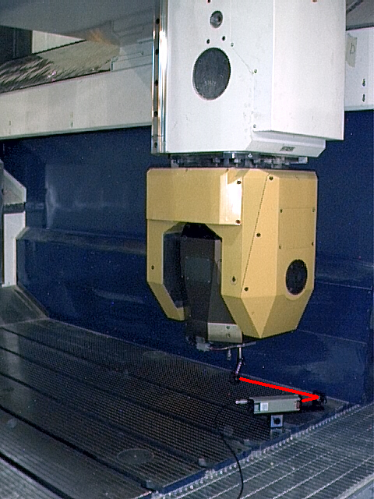
Fig 1-Machine I under test,
with the laser on the table and the retroreflector on spindle.

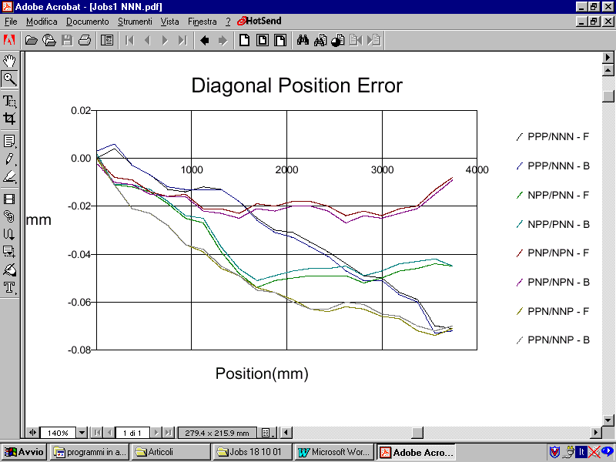

Fig 2 Volumetric Positioning error of the 4 diagonals
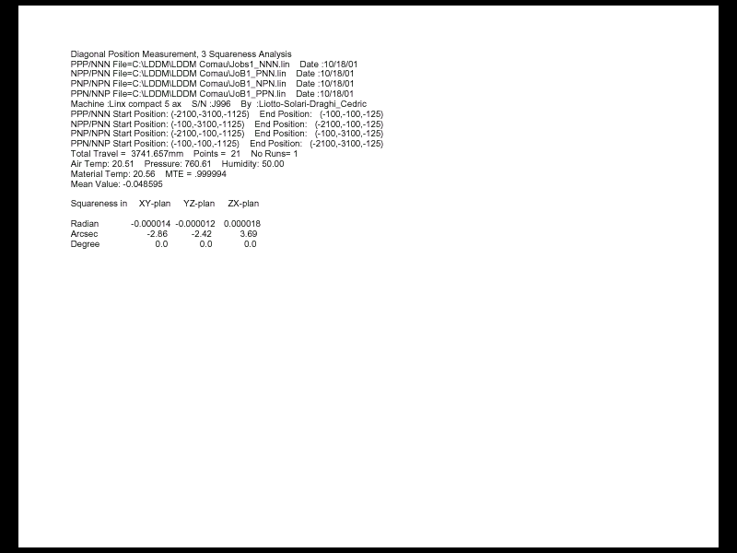

Errore di squadra

Fig. 3 Squareness error

from the diagonals length it is calculated, with extreme accuracy, the squareness errors on the total travel length.

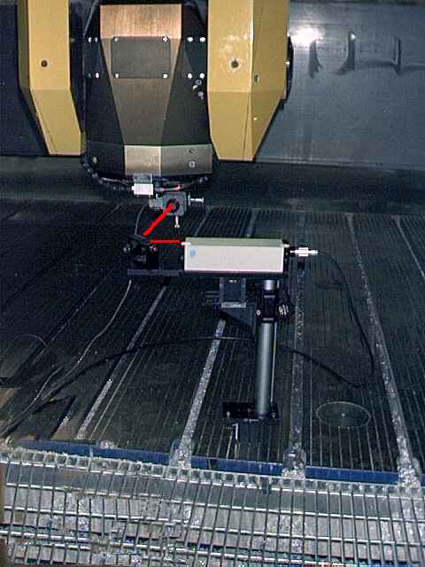
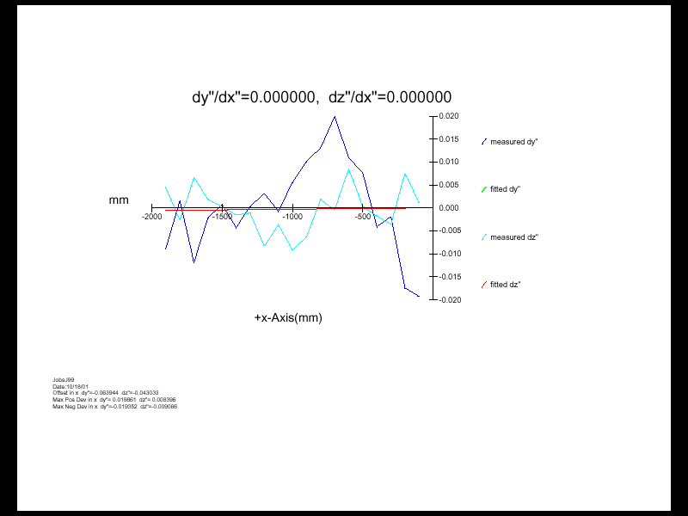
Fig 4 SRAIGHTNESS MEASUREMENT along the X axis into the two perpendicular directions Y and Z at the same time.

Measurement done with the quad detector, lateral position sensor.
Fig 5 below
Straightness diagram on X axis.
dark blue deviation in Y direction or horizontal straightness
azure, vertical straightness in Z direction.

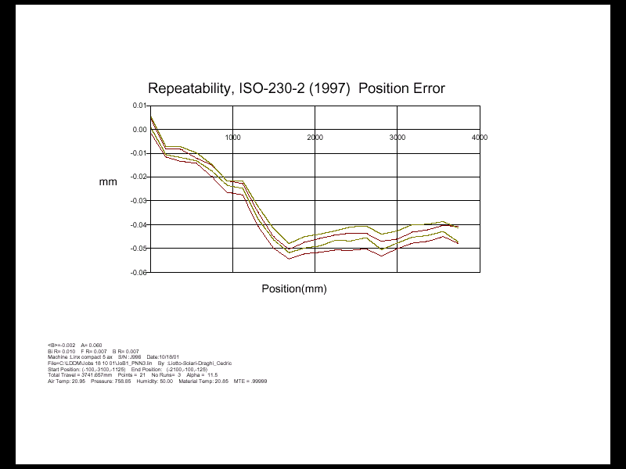

FIG 5 Statistical measurement performed 3 time in each direction on the PNN diagonal and analyzed according with ISO230 standard with deviation 2 sigma.

Fig 6 Backlash error along all the points of the diagonal

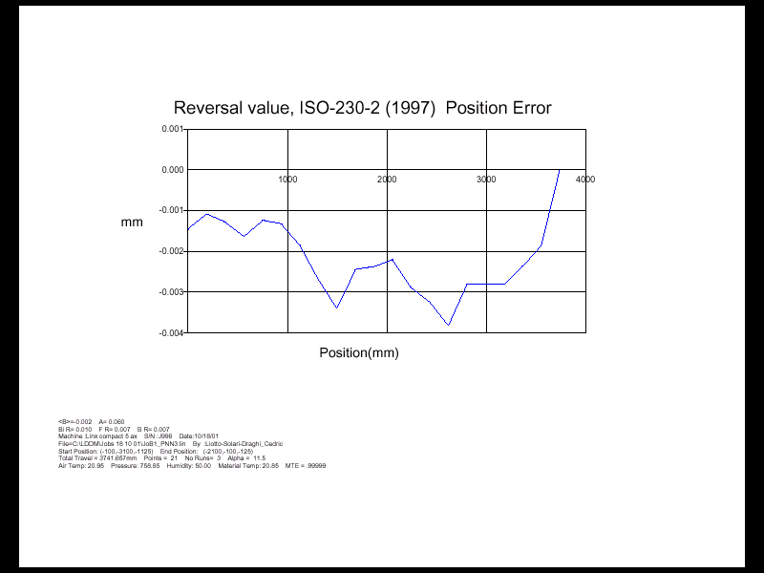

V. Vector (Step Diagonal) method, measurements and Compensation

- Measure preparation

The machine have been measured along the 4 body diagonals by means of interpolated movements of the 3 axes. The laser was mounted on the machine table and by the bending mirror the beam aligned parallel to the diagonal. The Flat Mirror was connected to the spindle with the surface perpendicular to the beam, as shown in the fig. 7. The machine was programmed to move the spindle starting from one corner and arriving to the opposite corner. All the compensation in the CNC controller was zeroed. The Laser beam was aligned parallel to the to the diagonal movement. the typical tolerance alignment is better than 0.25 m Rad. or 1mm at 4 m distance

2. Measuring system
The positioning error was measured by a single aperture laser Doppler (LDDM). Have been measured the Air temperature and pressure in order to compensate the speed light and the machine temperature in order to compensate the thermal material expansion.

- Collection and Analysis of the Volumetric errors
The data was automatically collected by the software LDDM at every machine stop at each singular axis movement. The error data have been analyzed by the LDDM software, clicking on 4-diagonal on the analysis section and loading the four collected diagonal data files. Was automatically calculated the errors for each axes, in tables or graphic form, fig 10, 11 and 12. And also generated the graphic that reassume the volumetric error of the machine (not compensated) as shown in fig 8.

4. Generation of Compensation error tables

At the end of error analysis, provided easily and automatically by the Windows LDDM software have been automatically generated the 24 bi-directional correction tables and the .SAG compensation table that have been loaded in the Siemens 840D CNC controller by a floppy disk.

The 24 compensation tables of 41 points each for a total of 984 points are related to :
No 3 tables for linear pitch error for X, Y e Z;
No 6 tables, (2 each axis) for the straightness of the orthogonal axes to each axis;
No 3 tables for the gantry (AX10) axis compensation ( in order for AX10 to copy AX1 and move . together parallel) ;
All the tables are repeated for the return travel.

Here follows an example of the compensation file

%_N_NC_CEC_INI

CHANDATA(1)
$AN_CEC[0,0]=0.0000
$AN_CEC[0,1]=+0.0001
$AN_CEC[0,2]=+0.0000
. . . . . . . . . . . . . . . . . . . . .

$AN_CEC[0,37]=-0.0019
$AN_CEC[0,38]=-0.0016
$AN_CEC[0,39]=-0.0025
$AN_CEC[0,40]=-0.0037
$AN_CEC_INPUT_AXIS[0]=(AX1)
$AN_CEC_OUTPUT_AXIS[0]=(AX1)
$AN_CEC_STEP[0]=+50.0000
$AN_CEC_MIN[0]=-2100.0000
$AN_CEC_MAX[0]=-100.0000
$AN_CEC_DIRECTION[0]=1
$AN_CEC_MULT_BY_TABLE[0]=0
$AN_CEC_IS_MODULO[0]=0
$AN_CEC[1,0]=+0.0008
$AN_CEC[1,1]=+0.0006
$AN_CEC[1,2]=+0.0007
$AN_CEC[1,3]=+0.0007
$AN_CEC[1,4]=+0.0029

. . . . . . . . . . . . . . . . . . . . .

. . . . . . . . . . . . . . . . . . . . .

$AN_CEC[23,33]=-0.0021
$AN_CEC[23,34]=-0.0041
$AN_CEC[23,35]=-0.0053
$AN_CEC[23,36]=-0.0056
$AN_CEC[23,37]=-0.0060
$AN_CEC[23,38]=-0.0061
$AN_CEC[23,39]=-0.0084
$AN_CEC[23,40]=-0.0085
$AN_CEC_INPUT_AXIS[23]=(AX3)
$AN_CEC_OUTPUT_AXIS[23]=(AX10)
$AN_CEC_STEP[23]=+25.0000
$AN_CEC_MIN[23]=-1125.0000
$AN_CEC_MAX[23]=-125.0000
$AN_CEC_DIRECTION[23]=-1
$AN_CEC_MULT_BY_TABLE[23]=0
$AN_CEC_IS_MODULO[23]=0
M17

5. Compensation Verification

The validity of the compensation was performed by means of 4 interpolated diagonal as indicated in the B5.54, ref. 4 (or ISO 230) with the compensation activated . The results of the compensation, in the same scale utilized in the graphic before compensation, is reported in Fig. 9

6. Measuring errors on the step diagonal
The accuracy of the laser system is very high, better than 1ppm, the typical error sources are: aligning errors or cosine error, errors due to the temperatures measurement and pressure. The error in the step diagonal measurements it is necessary to take in consideration other errors that are typical of the vector method:
Flat mirror alignment error, that depends from the misalignment errors and from the step size. The error can be quite large, but it is constant and is removed by the software.
Angular error, the reflector should not be in the center of rotation of the machine and generate a large error that is measured together with the linear and straightness error. It is possible to determine the rotational angles changing the measure sequence without to change the laser alignment. The rotational errors cannot be used for the correction in the largest part of the CNC controllers.
.

7. Error Budget in the step diagonal measurement

The variables are the followings:

Temperature control 0,1°C
Pressure control 0,5 mBar
total run lenght 4 m
dead path 100 mm
Tilt angle 20 μ Radiant
Misalignment error 0,25 mRadiant
expansion coefficient 12 μ / m / C°
Abbe offset 50mm
Laser wavelength error 1 μm /m

Error calculation:

Air temperature compensation 1ppm x 4m x 0,1 °C = 0,4 μm
Air pressure compensation 0,3 ppm X4m X0,5mBar = 0,6 μm
Material expansion 12 μ / m / C° x 4m x 0,1 °C = 4,8 μm
Dead path 1ppm x100 mm x 0,1°c = 0,01 μm
Abbe error 0,05m x 20 μ Radiant = 2 μm
Cosine error 0,25 ² mRad. /2 x 4m = 0,125μm
Wavelength error 1ppm x 4m = 4 μm

The total error or the measurement uncertainly is:

E= 0,4 ² +0,6 ² + 4,8 ² + 0,01 ² + 2 ² + 0,125 ² + 4 ² = 6,6μm o 1,65 μm/m
.26 μ inch or .065 μ inch/inch

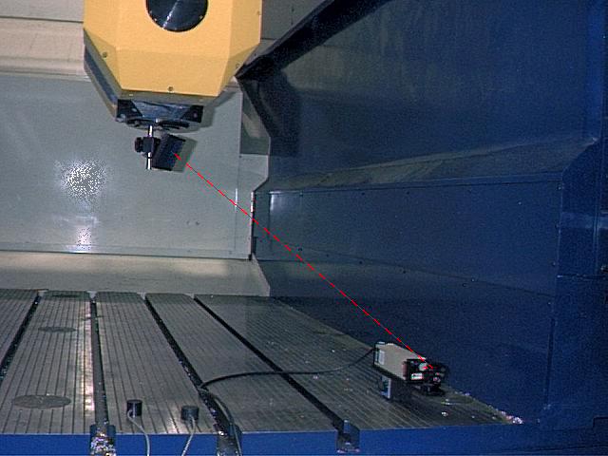

Fig . 7 Step Diagonal measurement with the laser on the table and the flat mirror on the spindle.

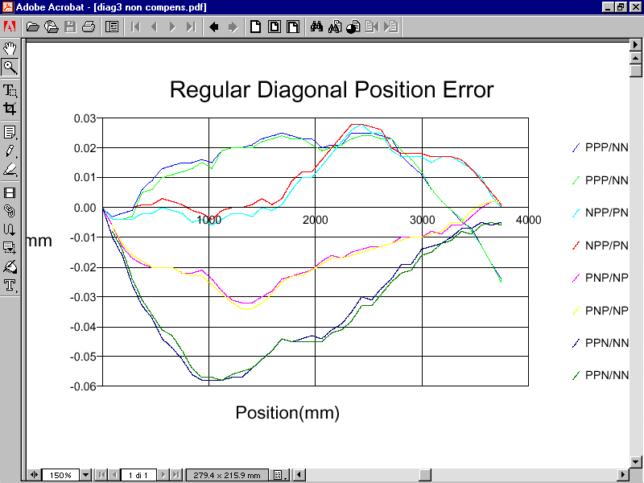

Fig 8 Diagonal positioning error before the compensation. The total error is 90 micron(.0022").

Fig 9 below Positioning error after compensation (same scale). The total error is reduced to 30 micron (.0007").
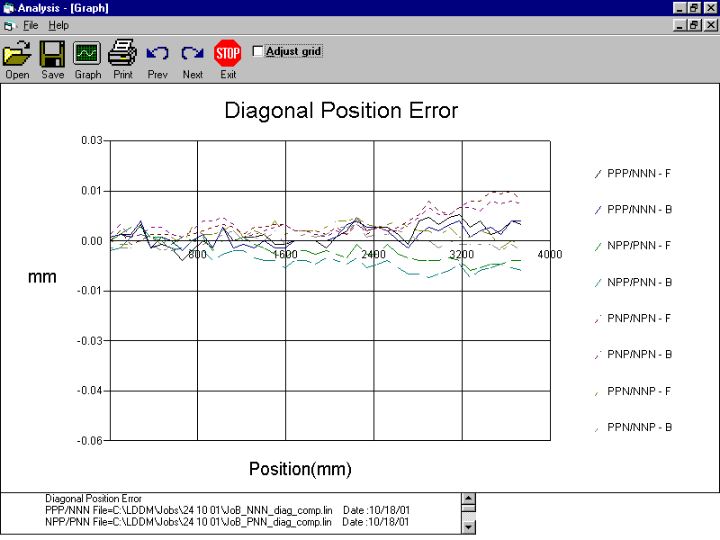

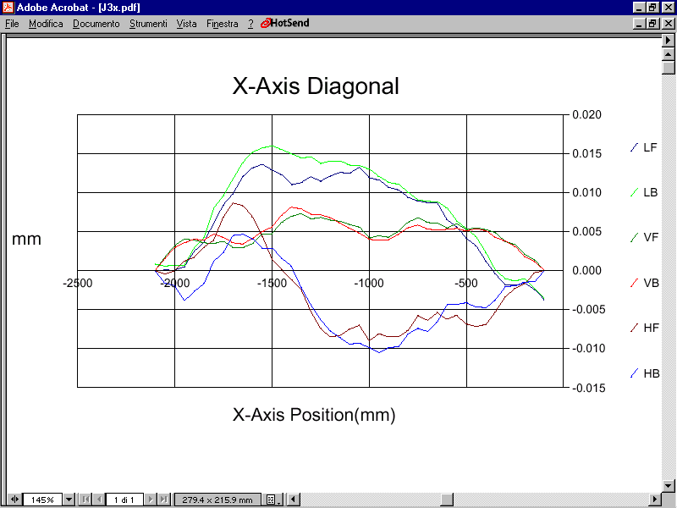

Fig 10 (above) errors on the X axis; the upper curves are the bi-directional linear position error,
the curves in the middle are the straightness error in direction Y and the lower curves are the errors in Z direction.
Fig 11(below) errors on Y axis, the upper curve is the linear positioning error,the green and red curves, the straightness error along X and the brown and blue curves are the error in Z direction.
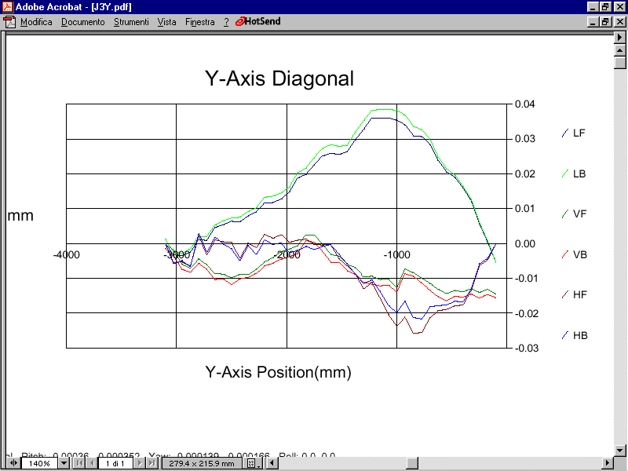

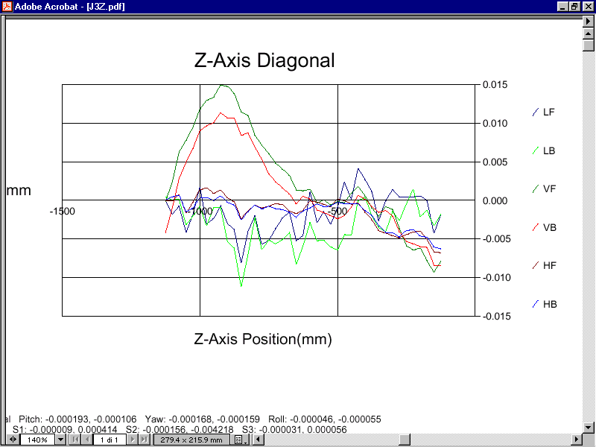

Fig 12 errors related to Z axis, LF and LB are the linear error, VF e VB are the straightness error in X direction and HF and HB are the straightness error in Y direction.

Fig 13 Compensation verification by the interpolated diagonal. All the axes are moving together in order to follow the diagonal line.
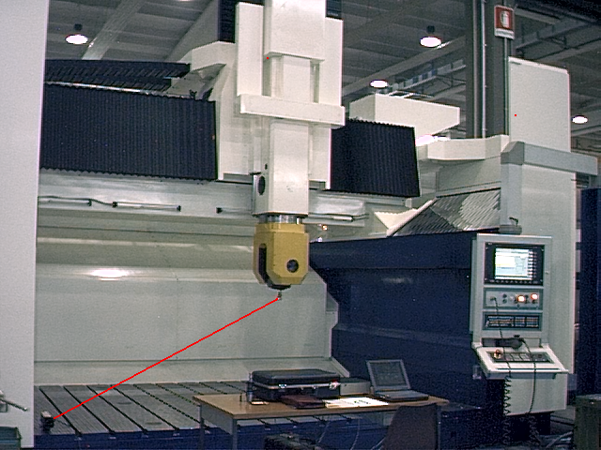

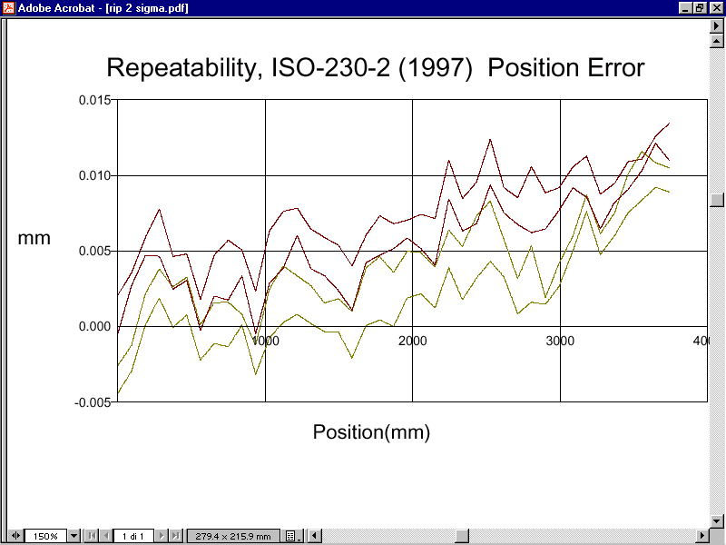

Fig. 14 Statistical error obtained by 3 bidirectional travel and elaboration accordingly with ISO-230-2 of 1997 . The red traces are the average + and - 2sigma for the forward movement. The yellow traces is the return movement.

VI. DYNAMIC MEASUREMENTS WITH ARMONIC EXCITATION.
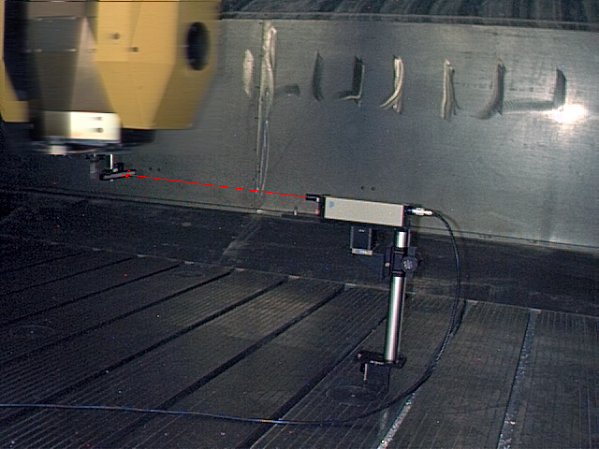

Fig. 15 Circular interpolation or Laser Ballbar on the XY plane. Feed 5000 mm/min (200"/min) diam. 50mm (2")
Fig. 16 Table of the results of the circularity test.
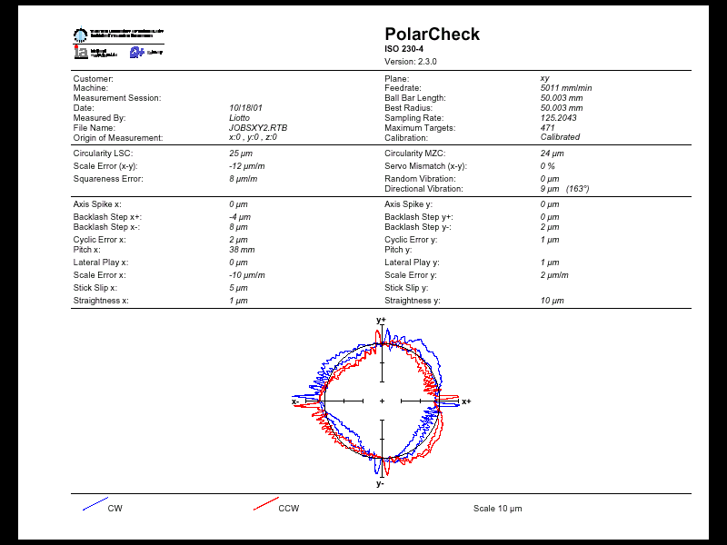

GRAPHICS OF HARMONIC ANALISYS RELATED TO THE SINUSOIDAL EXITATION the same data files of the laser ballbar measurements elaborated for dynamic errors.

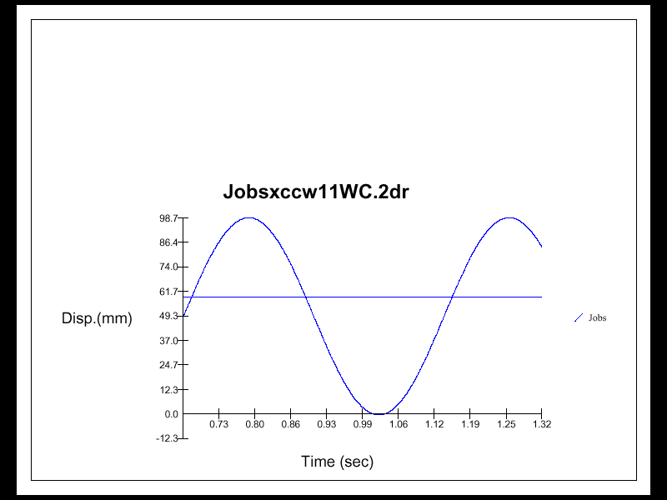

Fig.17 POSITION
THERE ARE
NO VISIBLE DISTORSIONS

Fig.18 SPEED
no visible distorsions

Fig19 ACCELERATION
the shape remain sinusoidal, it means the driver is tuned correctly. It is possible to note littlle oscillation at the direction changement of direction.

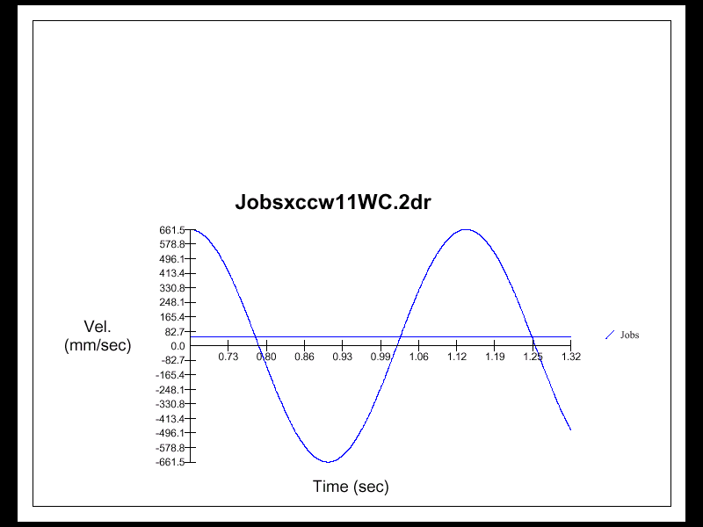

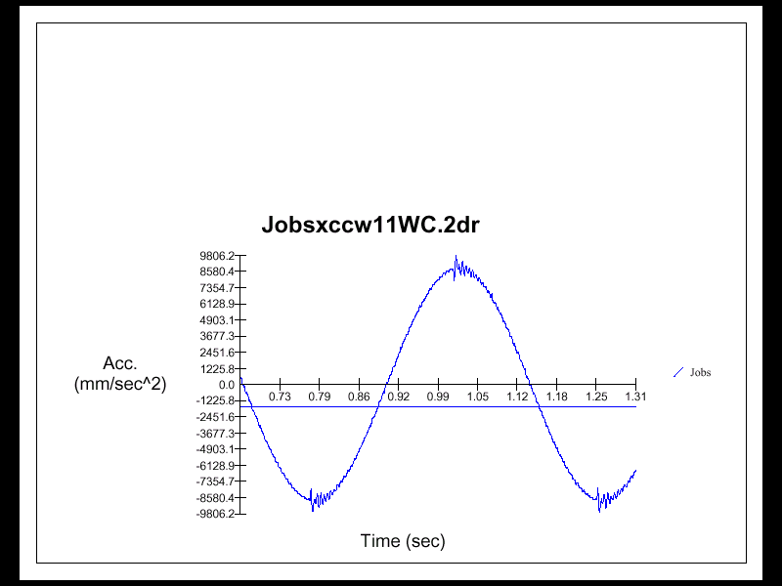

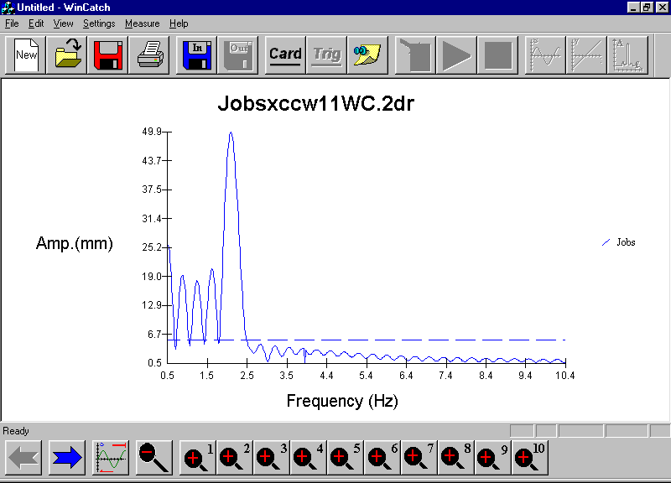

Fig 20 Frequency response in the ballbar measurement. The presence of one frequency only, the rotational frequency of 2 Hz (there is no substantial presence of both the second and third harmonics), denoted near to zero distortion in the axes movement. This representation in the frequency domain reassume in good approximation the results shows in the previous 3 figures.

VII. DYNAMIC MEASUREMENT WITH STEP EXITATION.

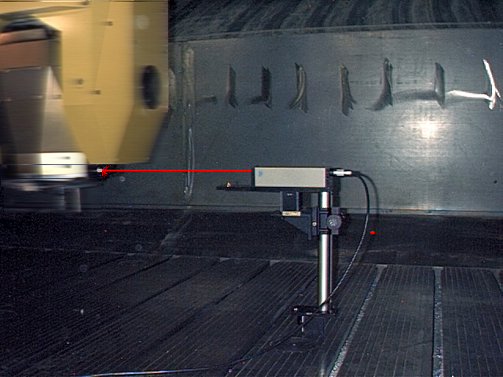
Fig 21 Linear step movement with the use of a 3mm diameter reflector in order to eliminate the vibration of the target support. Displacement is 1m (40")along Y feed 50m/min (2000"/min)
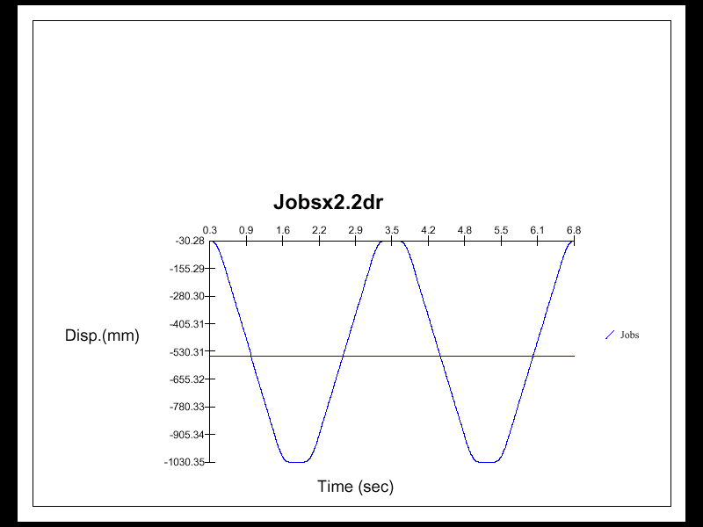

Fig.22
Grafic of the displacement collected dynamically.
with data rate of 1000 samples /sec.

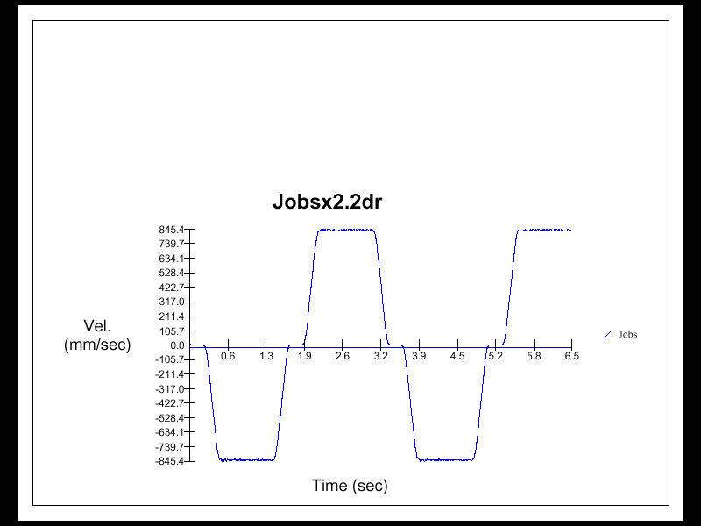

Fig 23 graphic of the speed

Fig 24 graphic of positioning with over-elongation and stop.

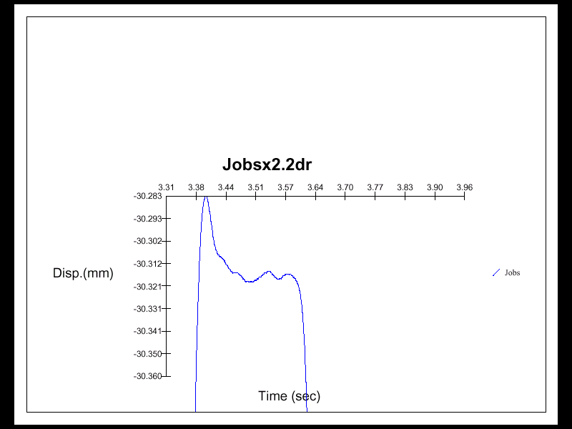

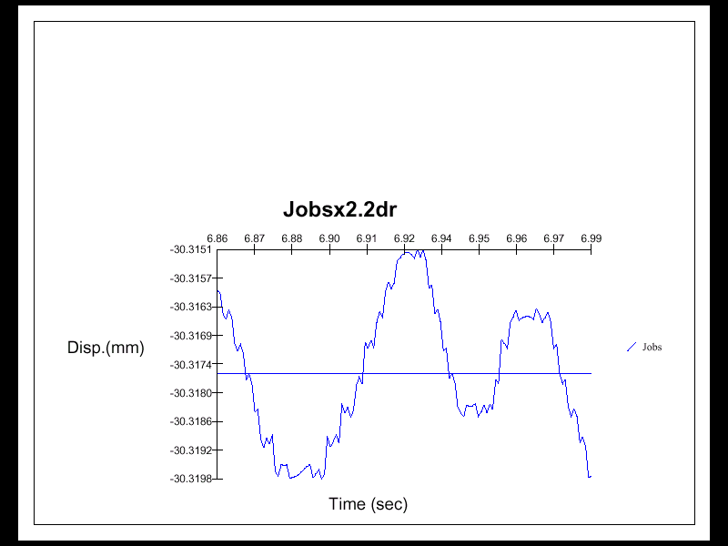
Fig 25 Enlargement of the zone with the axis stopped (see fig 24), zoom X1000

Fig 26 acceleration in the step movement. It is possible to note the two contiguous picks, respectively the braking and acceleration phase, they overcame 0.4 g.
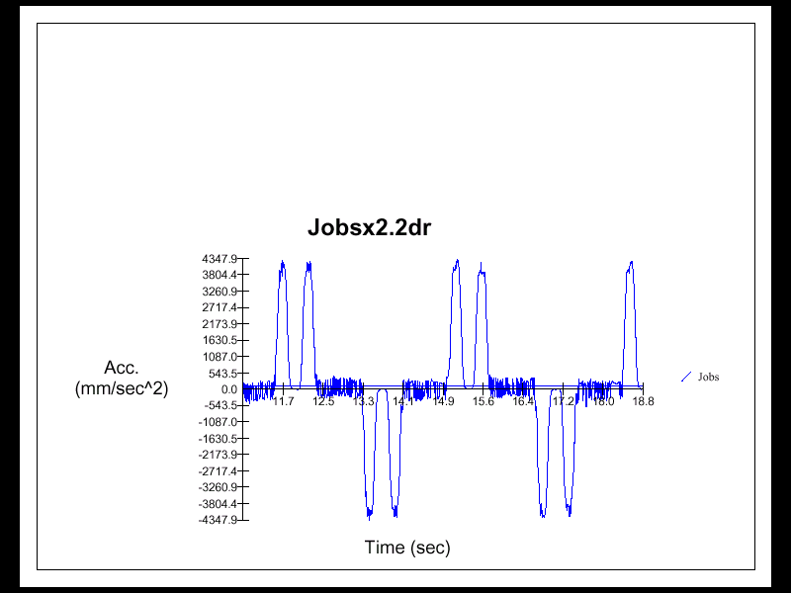

Fig. 27 Servo error during the constant speed movement. Scale in mm e milli seconds
(.06mm= .0025")

- Results and conclusions

The measurements on the first machine had a volumetric error of 80 micron (3.2 microinch) due mainly to the geometrical errors. Squareness errors of 12, 14 and 18 μm /m (μinch/ inch) respectively for XY, XZ and YZ and for straightness , for example was measured a vertical straightness error (dZ) along the X axis of 20 micron (.8 microinch) and an horizontal straightness (dy) of 40 micron (1.6microinch). But was not possible to do further compensation with the data collected.
The second machine, that was Vector compensated and passed from 90 micron to 30 micron.

The collected data confirms that with the Vector method it is possible to obtain improvement of the volumetric accuracy in relatively large machines, with a working volume of 6 cube meter, and certificate the performances. The all work is performed in 4/8 hours only against 24/30 hours spent with the traditional methods and without typing errors due to the manual compilation of the tables.

IX. References and bibliography
1-An American National Standard ASME B5.54-1992 (1992)

2-Charles P. Wang A Laser Vector measurament Technique …, Part 1: Basic Theory
Rev. Scientific Instrument-Oct. 2000 – (2000)

3-G. Liotto and C.P.Wang “ Laser Doppler Displacement Meter (LDDM) allow new
diagonal measurement for large aspect ratio machine tool easily and accurately”,
Proceedings of LAMDAMAP International Conference of Laser Metrology and
Machine Performance, Huddersfield, West Yorkshire England, 15-17 July, 1997

