Nanometer Positioning by Laser Doppler Scale Feedback
and Multiple-Pass Optic,
an Application of High-Resolution Laser Interferometry

Charles P. Wang ,
Optodyne,inc. 1180 Mahalo place Compton, CA 90220
and
Gianmarco Liotto
Optodyne Laser Metrology srl Via Veneto, 5 20881-Bernareggio (MB)
tel.+39 039 6093618 optodyne@optodyne.it http://www.optodyne.it

ABSTRACT

We have collaborate with Argonne National Laboratarory (USA) for the design and realization, and testing for a closed loop positioning system with 1- Angstrom step and 50 mm maximum travel controlled with a Laser Doppler Scale (LDS) with sub-nanometric resolution and exceptional stability. The stability conjugated with high speed make possible the development of a multiple-pass optical arrangement used for increase the resolution to 3 tenth of nanometer and to minimize the effect of air turbulence. LDS have large displacement capability in respect with the micro positioning scale and due to high speed the capability to overcome the micro hart quark due to stick-slip friction. The LDDM® (Laser Doppler Displacement Meter) is a new generation two frequency interferometer based on the principles of radar, the Doppler effect, and optical heterodyning. The new frontier called nano-technology have the needs of transducers and actuators that are at the same time high performing and cost effective. With the Laser Doppler LDS and the multiple-pass optics make possible to design and manufacture closed loop positioning systems at high resolution, compact dimensions in order to produce industrial systems finalized to the production activity.

I. Introduction
High accuracy positioning systems in the nanometer range are needed for IC fabrication such as deep UV lithography, research in micro-electro-mechanical systems (MEMS) and nano technology. A linear encoder with sub-nanometer resolution is needed for such applications as large field x-ray lithography, large field scanning microscopes, x-ray microscopes, x-ray micro machining etc. For a conventional laser interferometer the resolution is about wavelenght/64 or 10 nm. With higher fringe interpolation, -Wavelenght/1024 or 0.6 nm can be achieved [1]. However, the major uncertainties are the optical non-linearity, electronic noises and detector shot noises [2]. For high resolution and high accuracy measurement in a laboratory environment, the measurement is effected by the environment such as mechanical and acoustic vibrations, thermal expansion, and air turbulence. Because of the air circulation, or turbulence, the effective laser beam path length (OPD) is fluctuating. This fluctuation limits the accuracy of the laser measurement. Long time-average has been used to minimize the effect of air turbulence. However, too much averaging may cause a time-lay and inconvenience in the measurement. Another method is to control the environment to minimize the air circulation and temperature gradient or to cover the laser beam path completely. However, in a shop environment, both of these are difficult to achieve. To overcome these difficulties, a laser Doppler displacement meter (LDDM) with a 6-pass (up to 24-pass) optical arrangement is used to achieve sub-nanometer resolution with a measuring range of 100 mm and a maximum velocity of 600 mm/sec. The optical setup is compact and easy to align. As compare with a laser interferometer, the advantages are: higher resolution, less effected by air turbulence, less shot noises, less non-linear phase distortion, and less non-linearity error.

II Laser interferometers in a laboratory environment
There are optical, electrical, and environmental limitations on high fringe interpolation to achieve high resolution in a laboratory environment. The optical non-linearity or non-linear phase distortion is a fundamental limit on the accuracy of the heterodyne Michelson interferometer caused by leakage of the frequency components in the beam splitter [2]. A typical optical non-linearitv is 6 nm [4] For high fringe interpolation, high signal-to-noise ratio (S/N) is important. Reducing the electronic noises in the circuit and the shot noises in the photo-detector will increase the S/N, and also improving the laser alignment will increase the fringe contrast or the S/N.
Usually, the material thermal expansion is the largest source of error in the positioning accuracy However with controlled room temperature and using invar material (thermal expansion coefficient is near zero at room temperature), the effect of thermal expansion can be minimized. Air turbulence or index of refraction fluctuation is the most commonly discussed error source in interferometer accuracy. Small thermal gradients are present m the environment. Because the thermal diffusivity of air is low (0.2 cm-2/sec), the thermal in-homogeneities are mixed by the airflow before they reach equilibrium. In a region 10 cm long, the time scale for thermal equilibrium is 500 sec while the transit time for a 100 LFM flow is 0.2 sec. Hence the time scale for turbulence is from a few msec up 200 msec. Mechanical vibration is another source of errors. These are the vibration of the floor and sonic frequencies
transmitted through air and through the supporting structure. A table with good vibration isolation and damping is essential. With proper isolation, damping and acoustic shielding, the effect of thermal heating mechanical and acoustic vibrations can be minimized.

III. Laser interferometer and Single aperture laser Doppler system
Conventional laser interferometers are based on the Michaelson interferometer. There are two laser beams the output beam and the return beam. which are parallel but displaced about 25 mm. Hence, large optics is required. Also, the alignment is critical, 3 elements have to be aliened co-axially. The single-aperture LDDM laser system is based on laser Dopplermetry. The laser head is very compact (25 mm x 25 mm x 202 mm) and is completed with stabilization circuits, electro-optics, and photo-detectors. The output beam and the return beam share the same aperture Hence large optics is not required. Hence it is more compact and flexible. The major features of the LDDM single-aperture laser system are compact, small laser head and reflector high resolution and high accuracy, versatile and flexible. The laser stability is 0.1 ppm the laser system accuracy is 1 ppm, the resolution is 2 nm, the maximum range is 5 m, and the maximum speed is 5 m/sec.

A commercial Laser Doppler Displacement Meter (LDDM) system includes four components: a laser head, a processor module, a display module, and a target reflector. The laser head houses a frequency-stabilized HeNe laser, an electro-optic assembly and a photodetector, which functions as a receiver. The laser light reflected by the target is frequency shifted by the motion of the target. The photodetector measures the phase variation caused by the frequency shift, which corresponds to the displacement of the target.
When the displacement is larger than the half-wavelength, wavelenght/2, a counter records the total phase changes as:
Δφ total = 2π Ν + φ (1)

where N is the number of half-wavelengths, and φ is the phase angle less than 2π.

The total target displacement, Δz, can be expressed as:

c
Δz = ------ (N + φ/2π) (2)
2f0 ,

where f0 is the frequency of the laser, and c is the speed of the light.
If we make the laser light reflecting back and forth M times between the fixed base and the target before it finally reach the photodetector, then introducing equation (2) gives
c
Δz = --------- (N + φ/2π) (3)

2f0 M ,

which indicates that the multiple-reflection optics provides M-times resolution extension power for the system.

The laser Doppler displacement meter is based on the principles of radar, the Doppler effect, and optical heterodyning. We have chosen a LDDM as our basic system, not only because of its high resolution
(2 nm typically) and high measuring speed (2 m/s) but also because of its unique performance independent of polarization, which provides the convenience to create a novel multiple-reflection-based optical design to attain sub-Angstrom linear resolution extension.

IV. Multiple-pass optical arrangement
For a typical laser interferometer. the laser beam is reflected by a retroreflector target, and the displacement of the target is determined by measuring the change in the optical path length. A multiple-pass is an optical arrangement, with the laser beam reflected back and forth between the retroreflector target and some mirrors or prisms mounted stationary with the laser head. It has been shown in Ref[3 4] that multiple-pass optical arrangement can increase the resolution, and reduce the effect of air turbulence.

Conventional multiple-pass optical arrangements using mirrors are rather complex, balky and difficult to align. Tins is because the conventional laser interferometer uses 2 apertures. A 6-pass optical arrangement developed by Optodyne can easily be achieved by attaching an optical adapter to the single aperture laser head and a 38 mm diameter retroreflector target as shown in Fig. 2. Using the property of a cube comer prism, the incident and reflected laser beam are always parallel. Hence the alignment becomes easy. The number of passes between the optical adapter and the retroreflector is increased by a factor of 6. In the 6-pass optical arrangement a 1 mm displacement of the retroreflector target becomes a 6 mm increment of the effective optical path length. Hence, the resolution is increased by a factor of 6 and the air turbulence is averaged over the 6 parallel paths. However, the maximum range and the maximum velocity are also reduced by a factor of 6. A factor of 12 is also possible with multiple comer cubes. A schematic of the 12- pass optical arrangement is shown in Fig. 1.
The major advantages of the 6-pass laser system arc: higher resolution, less effected by air turbulence, less sliot noises, and less non-linear phase distortion. The disadvantages are: shorter range, lower speed, more optical components and less lateral tolerance.

Performance test and results
The performance of a laser system with 6-pass optical arrangement was compared with a single-pass laser interferometer. Both laser systems were set up co-axially with both retroreflectors mounted together and with equal distances from the laser heads. A typical result is shown in Fig. 4. The heavy line is the fluctuation in the 6-pass optical arrangement and the light line is the fluctuation in a single-pass optical arrangement. The effect of air circulation or the change in refractive index, is reduced considerably in the 6-pass optical arrangement. To demonstrate the sub-nanometer resolution in the laboratory environment, a 12-pass optical arrangement with a PZT driver is used to move the stage at an increment of 0.2 nm.

VI. Summary and conclusion
In summary, a laser Doppler displacement meter with a multiple-pass optical arrangement has been developed by Optodyne. The performance is sub-nanometer resolution with a measuring range of 100 mm and a maximum velocity of 600 mm/sec. The optical setup is compact and easy to align. It is also less sensitive to the air turbulence.

References
1. 0. Karri, "Fundamental limit on accuracy in interferonietry", Optics Letters, Vol. 14, No. 13, pp 657-
658,July 1, 1989.
2. N. Bobroff, "Residual errors in laser interferometry from air turbulence and non-linearity", Applied
Optics, Vol. 26, No. 13, pp 2676-2682. July 1,1987,
3. D. Shu, E. Alp, J. Barraza, T. Kusay, and T. Mooney, ''Optical design for laser Doppler angular encoder
with sub-nrad sensitivity". .1. Synchrotron Radiation, Vol. 5, pp 826-828, 1998.
4. Y. Timimura, "A new differential laser interferometer with a multiplied optical path difference". Annals
of the CTRP Vol. 32. No. 1, pp449-453, 1983.
5.D. Shu, E. E. Alp, J. Barraza, T. M. Kuzay, and T. Mooney, A Novel Laser Doppler Linear Encoder Using Multiple-
Reflection Optical Design for High Resolution Linear Actuator, Proc. SPIE, Vol.3429 (1998) 284-292.

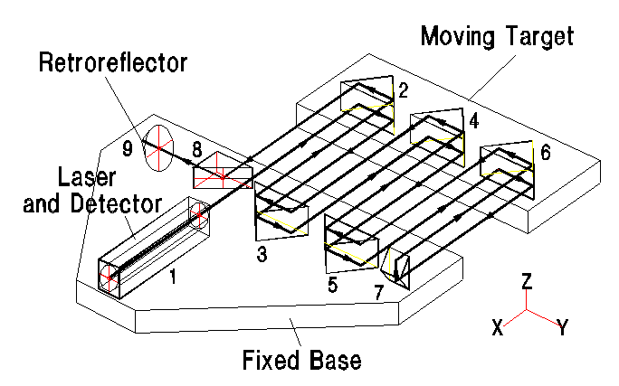

Fig. 1------Schematics of a multiple pass optical arrangement and laser beam path.

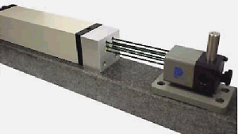

Fig 2, A 6 -pass optical adapter using an optical adaptor and a 38mm diameter retroreflector target.

Fig 3 test of 1 Angstrom (0,1nm) step movements

6 - p a s s v s s in g le

0 10 20 30 40 50 60 t i m e , s e c

0

-0,1μ

-0,5μ

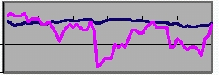
Multi 6
Single

MULTIPLE PASS ADAPTER

Fig 4 Effect of air circulation on a 6-pass optical arrangement
and on a single pass optical arrangement.

